READ ME FIRST!

Look in tbj5_assets for the base assets to use! Solving the mystery below is optional, but if you solve it, you will have MANY more assets to use!

If you want to solve it, read on…

DETECTIVE TOBY’S CASE
An investigative reporter, Toby Majox, was searching for recluse developer Max Tojoby.
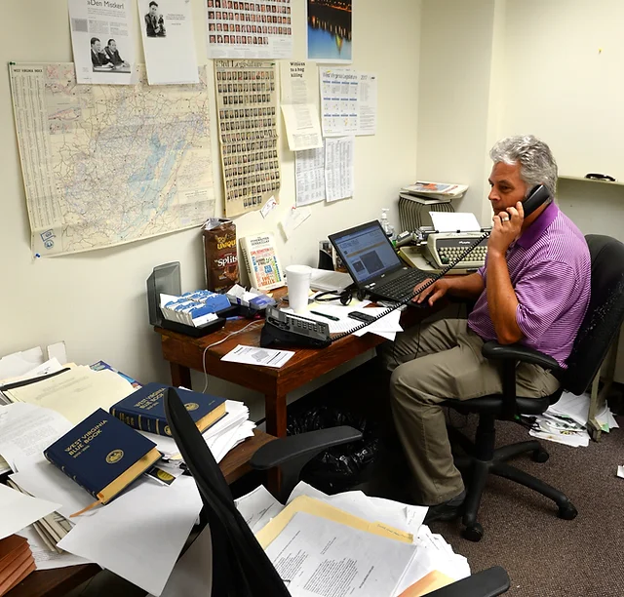
Read his story in “NOTES FROM TOJOBY INVESTIGATION”... then explore the items left behind. If you solve each clue, use that word, all lowercase, to unzip the correct file on the mysteriously-sent CD, and use all four sets of files to help solve the case!

